## Steps to execute PS script for Application Configuration

#### **MC SINK Server**

**Table of Contents**

Initial Steps 2

Prerequisites 2

Steps to perform unit testing 2

output of application configuration automation  6

MC SINK Server Script Details 6

#### Initial steps:

* User must have access to AWS account.

#### Prerequisites: (we are installing it through powershell scripts)

**Following software should be installed:**

1. Redistributable
2. Native client
3. Mysqlodbc(32-bit)
4. AWS CLI
5. SSM Agent
6. Cloudwatch Agent

**Two buckets should be created in S3:**

1. corecard-setup-files: where all the data of core card will be uploaded.
2. application-configuration-scripts: where all the PS scripts will be uploaded under Sink folder.
3. In **corecard-setup-files** there will be a folder of name **Prerequisites** which will contains all the prerequisites EXE & MSI files that needs to be installed.

**Steps to perform unit testing: (These steps should be performed for manual implementation)**

Step1. Search EC2 & click on EC2 and then click on launch instance

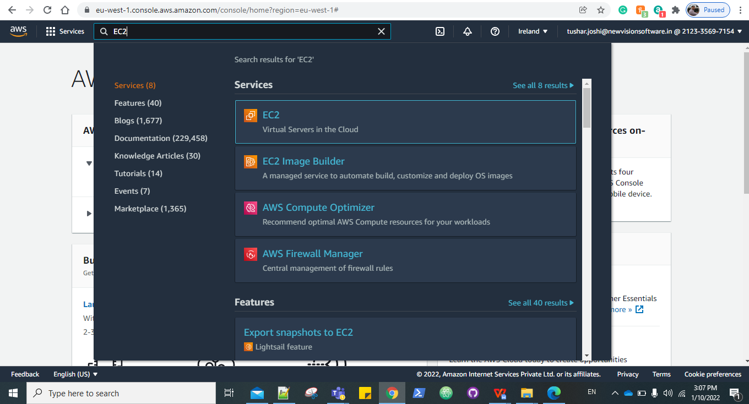

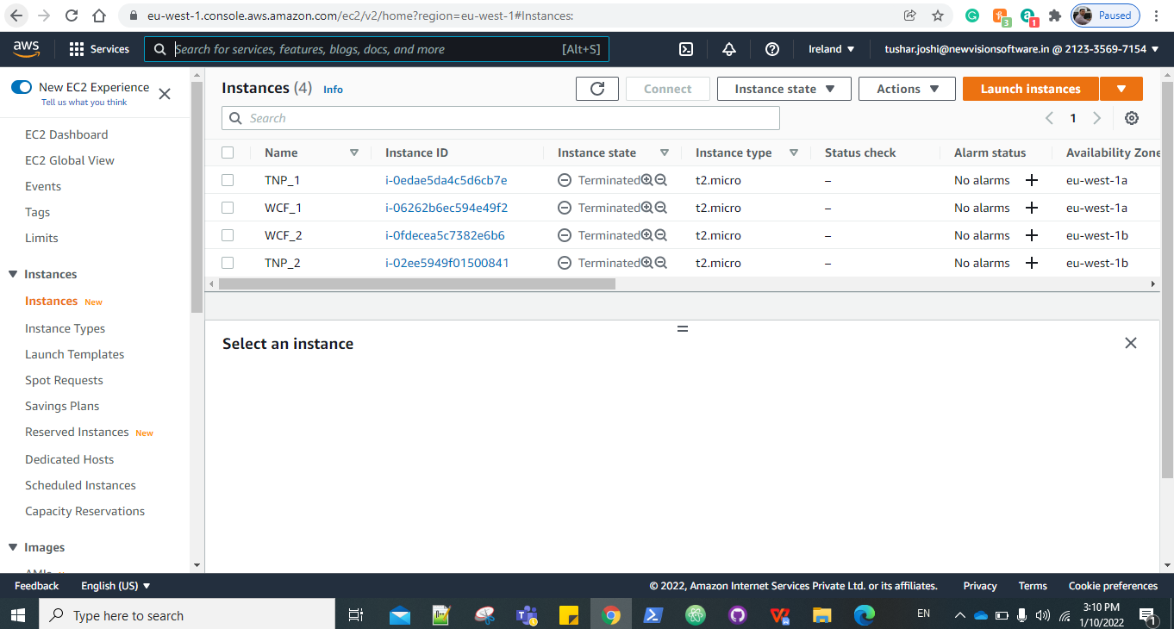

Step2.Choose Amazon machine image

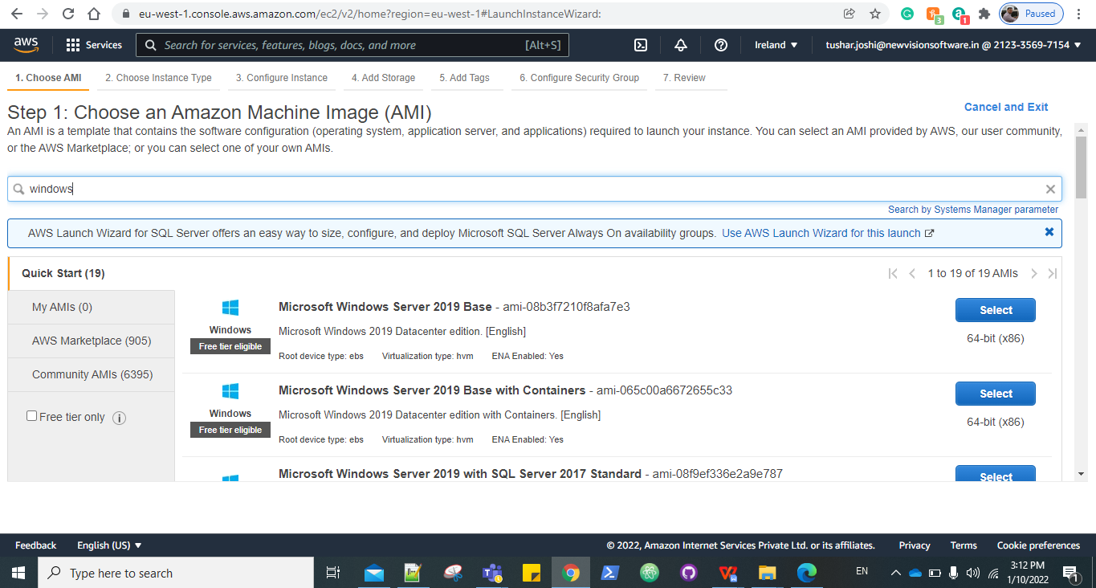

Step 3: Choose an Instance Type.

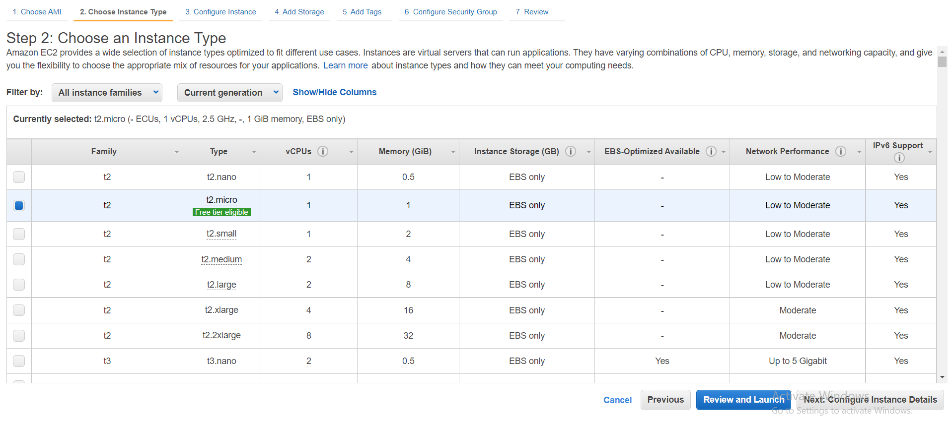

Step 4: In Configure Instance details select the no. of instances, Application_Configuration_VPC, and in user data paste the following command:

|  |
| --- |
| **<powershell>**  **#For Sink Server**  **Initialize-AWSDefaultconfiguration -AccessKey <AccessKey> -SecretKey <SecretKey> -Region us-east-2 Copy-S3Object -BucketName application-configuration-scripts -KeyPrefix Sink -LocalFolder C:\ -Force**  **#Hit following command after successfully copying data from s3 bucket**  **Powershell.exe -File C:\Master.ps1 </powershell>** |

Note: Enter you AWS access key and secret key ID.

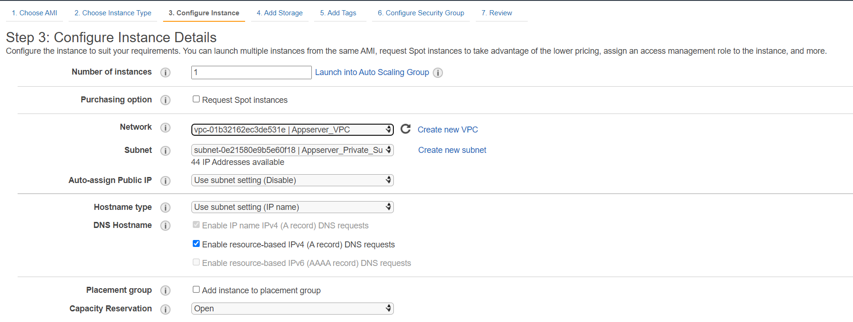

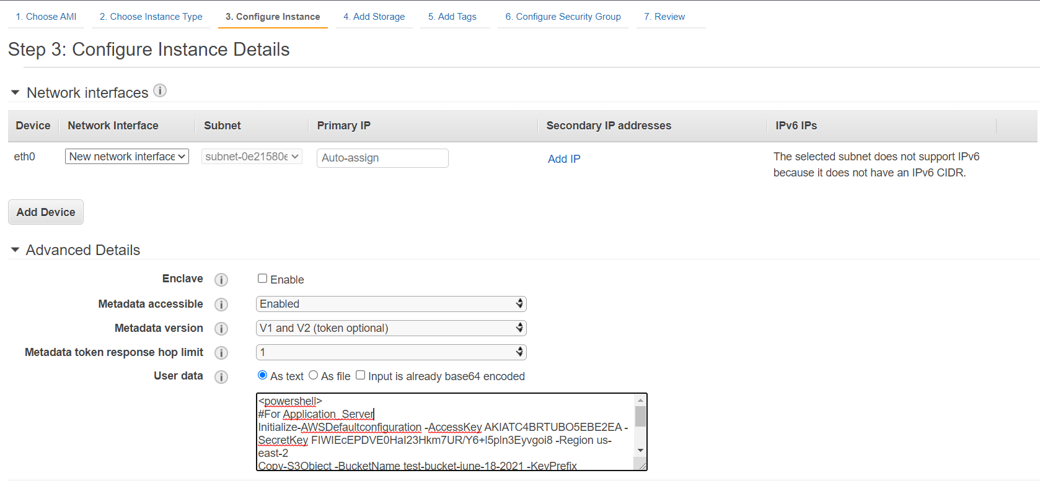

Step 5: Add storage.

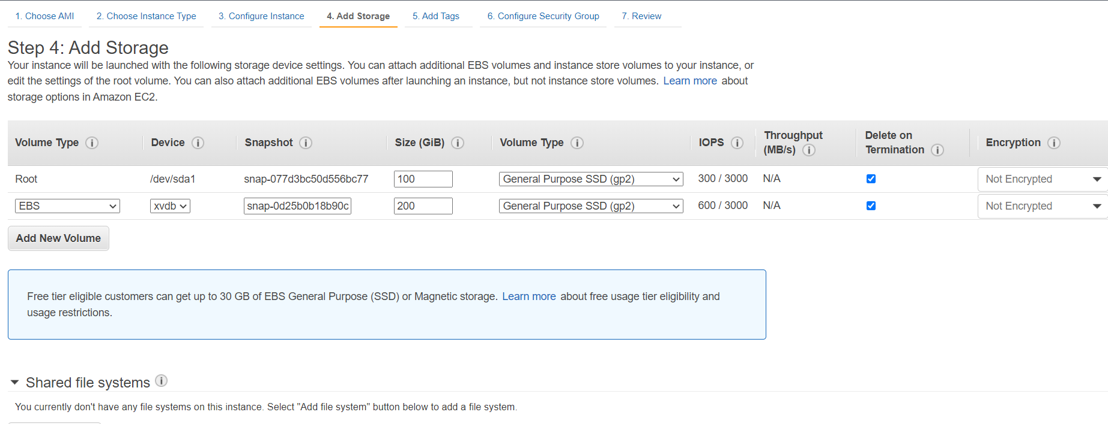

Step 6: Give the Tags if needed.

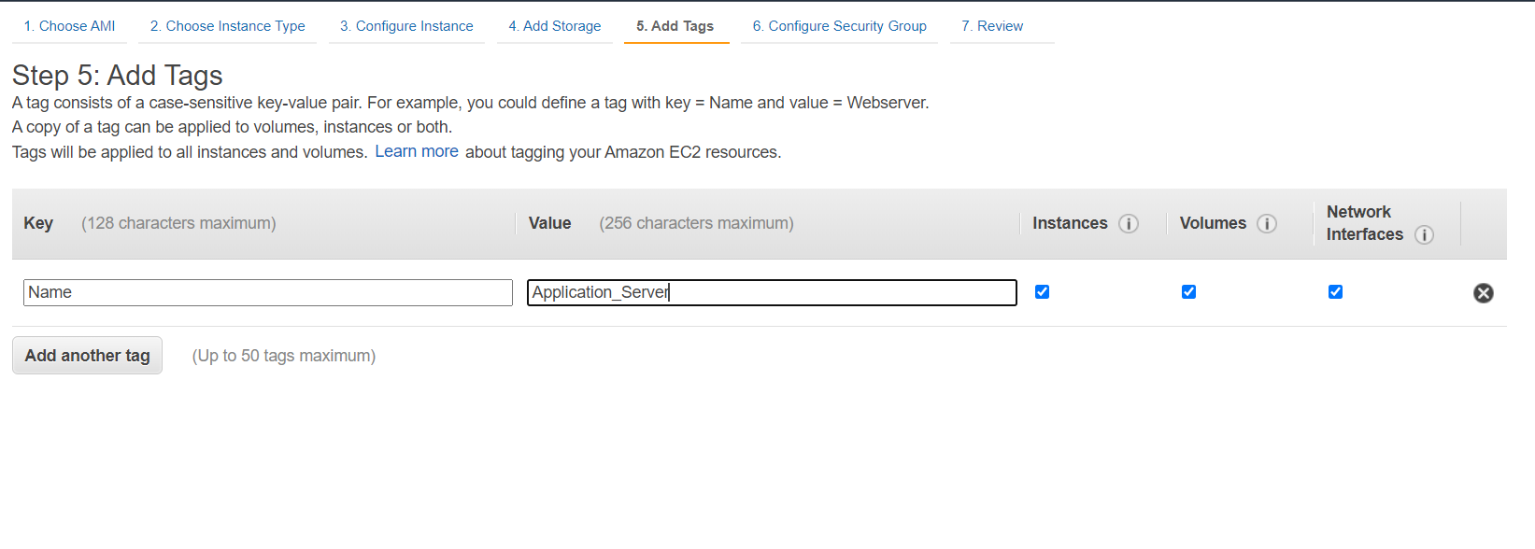

Step 7: Select the security group with name **Appserver_sg**.

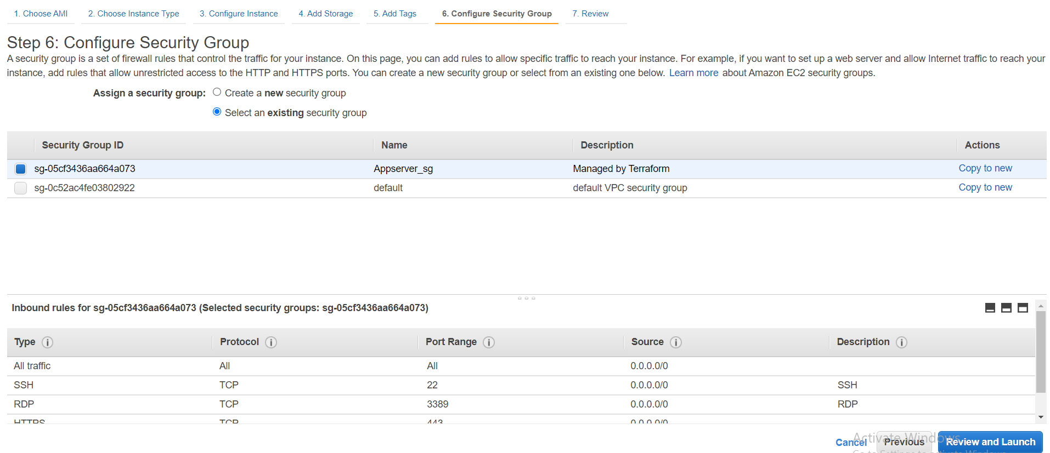

Step 8: Review and launch, Select the existing key pair or create new and launch.

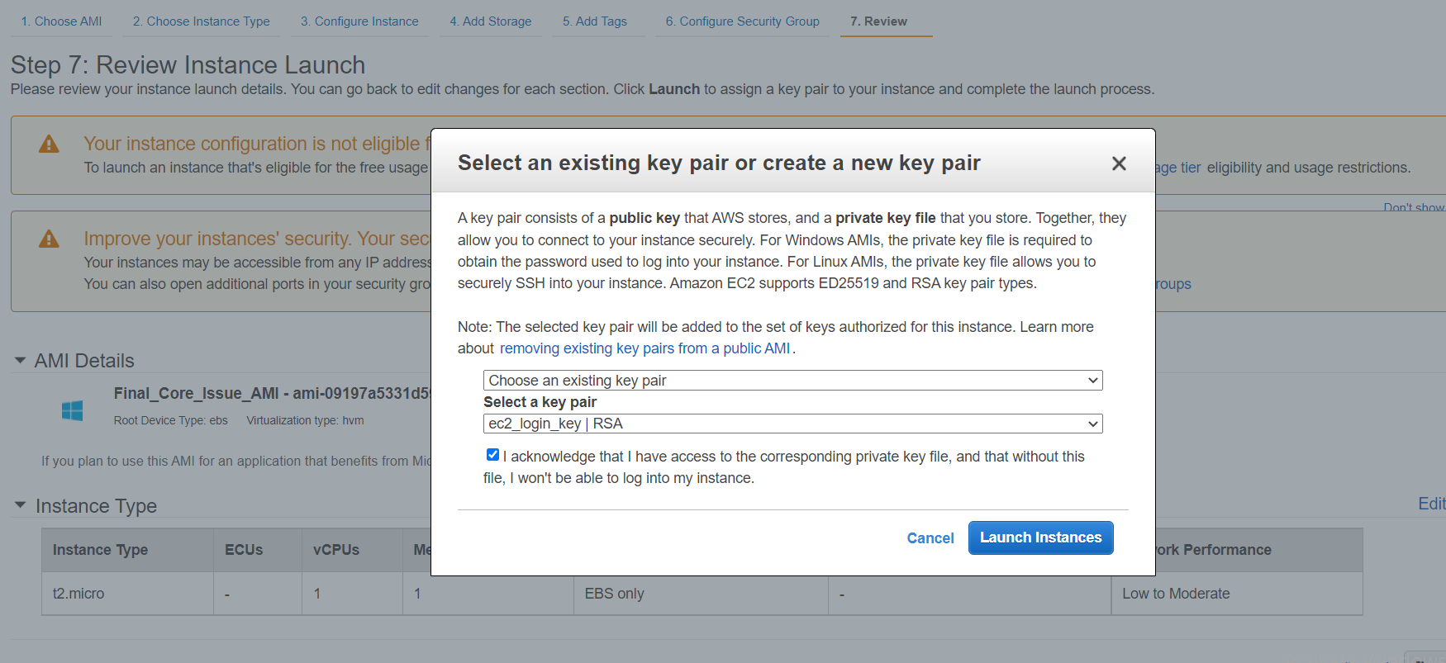

Step 9: It will take some time to configure the whole server and the scripts will be running in background.

#### **To see the output of application configuration automation:**

1. User should connect to bastion host.
2. Then, from bastion host user can connect to server through RDP.

#### **Application Server Script Details:**

In the S3 bucket all the files listed below are present:

**Note**: Please refer S3 bucket for updated files

1. **Administrator_password**: This script will set the password for user “Administrator”
2. **CI_Client_DSl :** This script file is used to import variables for each object of CI_client_var from path “C:\testvariable.xml “ and it will define the variables in lookuptable array.

Also it will check if the contents like $_.Key matching with $original_file.If it's matches then it will define the source path in $destination_file for those contents.

1. **Cleanup:** This script file is used to cleanup all related files from C & D drive. Once cleanup completed server will ask to permission to restart the machine.
2. **Core_Auth_Configuration:** This script file is used to import variables for each object of Core_Auth from path “C:\testvariable.xml “ and it will define the variables in lookuptable array.

Also it will check if the contents like $_.Key matching with $original_file.If it's matches then it will define the source path in $destination_file for those contents.

1. **Core_Issue_Config:** This script file is used to import variables for each object of Core_Issue from path “C:\testvariable.xml “ and it will define the variables in lookuptable array.

And then it will check if the contents like $_.Key matching with $original_file.If it's matches then it will define the source in $destination_file for those contents.

1. **CoreAuth_Client_DSL:** This script file is used to import variables for each object of Core Auth Client from path “C:\testvariable.xml “ and it will define the variables in lookuptable array.

And then it will check if the contents like $_.Key matching with $original_file.If it's matches then it will define the source path in $destination_file for those contents.

1. **Drive_Configuration:** This script is used to get the drive details where objects are raw, then it will initialize the disk and will create new partition with volume of NTFS filesystem
2. e**xtract_msi_from_dbbide:** This script is used to extract MSI by executing dbbide4.2.42.12.exe file & it will store the MSI file into C drive
3. **Extractzip:** This script is used to extract the contents from zip file D:\DBBSETUP\MonitoringScript.zip and store at DestinationPath D:\DBBSETUP. Then it will remove all zip file contents from LiteralPath.
4. **install_prerequisites**: This script is used to install all prerequisites as below:
5. INSTALL SQL NATIVE CLIENT 11
6. INSTALL REDISTRIBUTABLE FILE
7. INSTALL ZIP.EXE
8. AWS CLI
9. odbc DRIVER 17
10. CLOUD WATCH AGENT
11. SSM AGENT
12. Redistributable
13. **install-bddie:** This script is used to install DBBIDE4.2.42.12.msi application into path D:\CC_Runtime

12**. master:** This is master script used to execute all power shell scripts to configure application servers

13**. ODBC Setup:** This script is used to setup ODBC Driver 17 for SQL Server

1. **powershell_aws_commands:** This script will copy all the core card data from S3 bucket “corecard-setup-files”
2. **Powershell_commands:** This script is used to copy items from source to destination path
3. **powershell_new_directories:** This script is used to create directory “CC_Runtime“ under D drive:
4. **tls_script:** This script is used for Configuring IIS with SSL/TLS Deployments
5. **wfCommonAuth_DSL:** This script file is used to import variables for each object of Core Auth Client from “C:\testvariable.xml “ and it will define the variables in lookuptable array and then it will check if the contents like $_.Key matching with $original_file.If it's matches then it will define the source in $destination_file for those contents.
6. **Windows_Firewall_config:** This script is used to setup firewall configuration AppServer-Ports by allowing Inbound port numbers '4421','4422','4427'

1. **testvariable.xml:** In this xml file contains all the variables for all the servers, In this file the tag name will fetch all the variables for that specific environment Eg. <ENV>DEV</ENV>
2. **scale_file_creation:** This script will create scale file in D:DBBSET\Scalefiles, extention for scale file will be (.ini).  
   Script will get all ec2 instances based on AZ and naming convention,  
   all the EC2 instances with CC_SRC and CC_SINK name will be fetch from console and name of the instance will be saved in scale_mc.ini file along with 5011 and 5012 port number.  
   Scale has 2 section one Source which will have all the CC_SRC instance with 5011 port number and second section consist of SINK which will have all sink server name with 5012 port number.

Original file contains all the values which will be needed to set in destination file. for example base_var is declared in Core_Auth_Configuration.ps1 and it will set the value in destination file.

Original files are as below:

1. **CI_Client.DSL**
2. **CoreAuth_Client.DSL**
3. **wfCommonAuth.DSL**

**4.- CoreAuthSetup**

**5. SetupCI**